**Tutorial 15**

**Name**: Bhavin Patil

**Roll No:** 66

**TY-CS-D**

**Tut 15 Statement: Study of various types of Blockchain, to connect the Meta mask wallet with the local Ganache network**

Through a secure network, transactions and information exchange are carried out using blockchain technology. People utilize distributed ledger technology and blockchain technology in addition to digital currencies. Blockchain is being utilized for private networking and other applications where only authorized users of the network may have access. The system or network administrators must be contacted by any new nodes or users who want to get authorization as only they are permitted to administer the actions in this environment.

Private blockchain and public blockchain are the principal types of blockchain technology. Although it may also be noticed and referred to as consortium blockchain technology and hybrid blockchain technology depending on certain additional criteria and analyses. Every type of Blockchain, which operates on the peer-to-peer (P2P) network architecture, essentially comprises a cluster of nodes, it is crucial to highlight. Every node in the network has a copy of the shared ledger, which is also regularly updated and used to verify transactions as they are sent, received, and initiated. Given its extensive scope, analysts divided blockchain technology into the following three categories:

* Public Blockchain
* Private Blockchain
* Hybrid Blockchain

**1. Public Blockchain**

One of the most common types of Blockchain is one that is both open and decentralized. Additionally, under this form of Blockchain technology, anyone involved in transactions may essentially access computer networks. The validated individual essentially earns the transaction incentives in this case based on validation, and two other Proof-of-work and Proof-of-stake models are also being employed. Additionally, the public blockchain is a non-restrictive distributed ledger system that doesn't require any form of authorization; anybody with access can be given permission to see the data or a portion of the blockchain. Additionally, this type of Blockchain provides authorization for both current and historical information.

This is additionally employed for cryptocurrency mining and trading. The blockchains of Bitcoin and Litecoin are the most popular in this market. If tight security guidelines and procedures are followed, it is generally secure. It might be dangerous, though, if security rules are not followed. Examples of this kind of Blockchain include Litecoin, Ethereum, and Bitcoin.

According to experts, Bitcoin and Ethereum are two popular instances of public blockchains. The aspects that this sort of Blockchain is associated with are as follows:

* Exceptional Security and Privacy
* Flexible and Open Environment
* Anonymity
* Absence of rules, and rigid policies
* Complete Transparency
* Distributed Systems, etc.

**2. Private blockchains**

These blockchains have access features but they are closed and limited. This blockchain enables transaction approval with the help of the system administrator. These platforms are created by private blockchain solutions and have the following features:

* Complete privacy
* High efficiency
* Faster transaction times
* Better scalability
* Quickness.

Only closed systems and networks may be used with this kind of blockchain, which makes it beneficial for businesses and organizations where only a small number of people can participate. This particular blockchain has appropriate security, authorizations, permissions, and accessibility features. Experts claim that private blockchains are used for voting, asset ownership, supply chain management, identifying and managing digital identities, and more. There are certain popular private blockchains like Multichain, Hyperledger projects, Corda, etc

**3.** **Hybrid Blockchains**

These combine public and private blockchains and are necessary for improved governance and the accomplishment of more challenging objectives. Although hybrid blockchain is not open and interacts with both controlled and decentralised systems, it possesses the qualities of security, integrity, and transparency.

Compared to conventional blockchains, it provides a number of benefits. Maximum customizability in hybrid blockchains is seen as a key feature with both a private permission-based system and a public permission-less system. The benefits of the recordings from the ledger allow users to access some portions of these blockchain systems while the remainder may be documented or kept safe. Because hybrid blockchains are so flexible, users may easily join as private blockchain. This type of blockchain is able to enhance the security and transparency of the blockchain network.

**4. Consortium Blockchain**

It is a different kind of semi-decentralized blockchain that is capable of organizing the management of the blockchain network. This particular blockchain may do tasks even from a particular firm. Blockchain is used in places like banks, governments, and other organizations to communicate information and perform mining. Examples of this kind of cooperation include R3, Energy Web Foundation, and others.

# **Steps to connect the Meta mask wallet with the local Ganache network**

Ganache is a local blockchain which allows us to develop and test smart contracts easily. In today’s post, we will look at how we can start a development Ethereum blockchain in a few clicks, and we will look at the features provided by Ganache.

## Step 1:[Install Ganache Client](https://kimsereylam.com/metamask/2022/02/25/setup-local-development-blockchain-with-ganache.html" \l "install-ganache-client)

Ganache can be downloaded and installed from [the official site from Truffle suite](https://trufflesuite.com/ganache/).

Once installed, we can launch the application and we have the option to either have a *QuickStart* or to create a *New Workspace*.

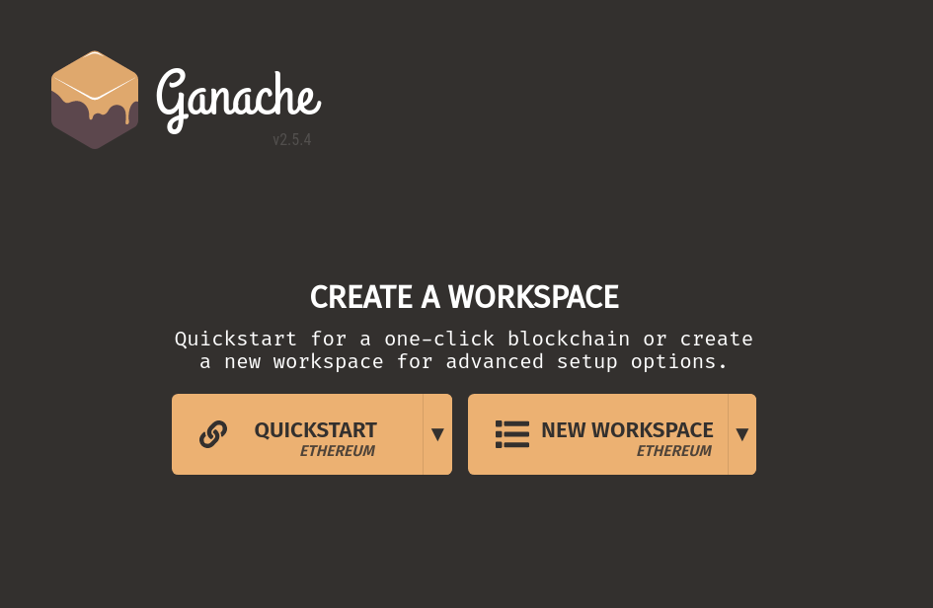

*QuickStart* will directly start a blockchain with accounts using default values while *New Workspace* gives us the opportunity to configure the blockchain prior starting it.

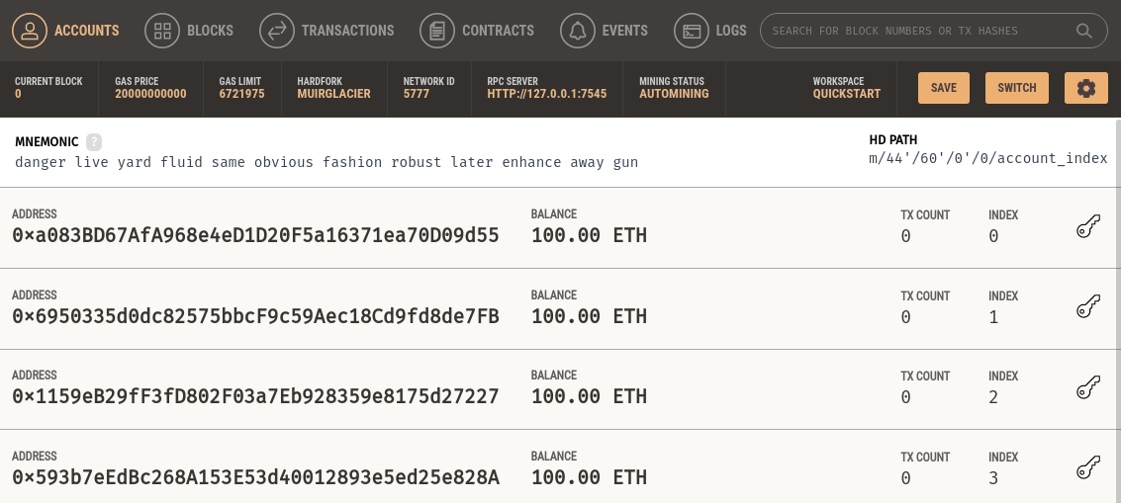

We can see that we directly get 10 accounts created with a balance of 100 ETH each. The UI allows us to explore the blockchain by looking at the blocks mined and the transactions happening on the blockchain.

## Step 2 :[Interacting with the Blockchain with Metamask](https://kimsereylam.com/metamask/2022/02/25/setup-local-development-blockchain-with-ganache.html" \l "interacting-with-the-blockchain-with-metamask)

The accounts created are created as part of a HD wallet with the mnemonic given in the UI. Using this mnemonic, we can import the accounts in a wallet like Metamask and connect to our local blockchain.

We can start by recovering the account from Metamask and then add the network with the RPC address given in Ganache HTTP://127.0.0.1:7545, with chain ID 1337.

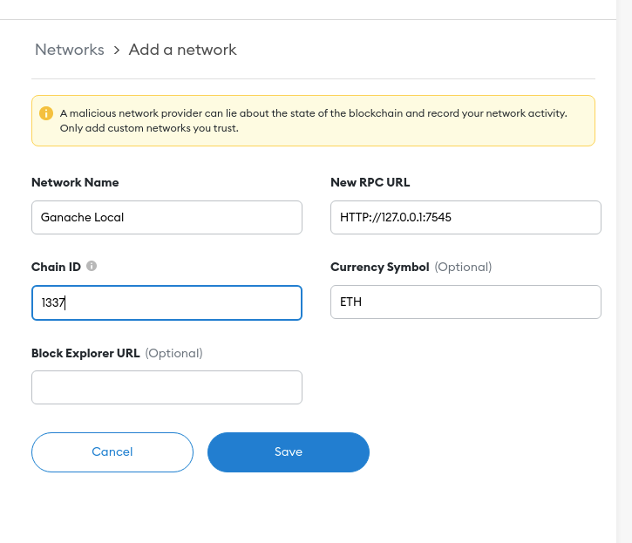

Once added, we can see that our account on the Ganache Local network has 100 ETH as expected since we are running on the blockchain setup by Ganache client.

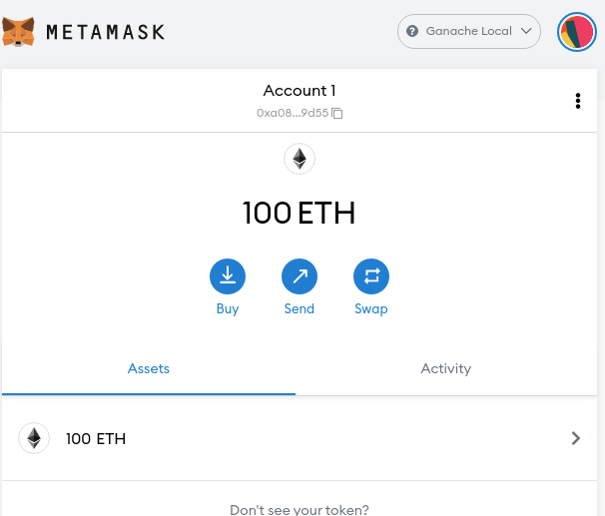

Now from Metamask, we can play around with the accounts ETH by doing transfers, for example we can take the public address from our second account 0x6950335d0dc82575bbcF9c59Aec18Cd9fd8de7FB and transfer 50 ETH from our current account.

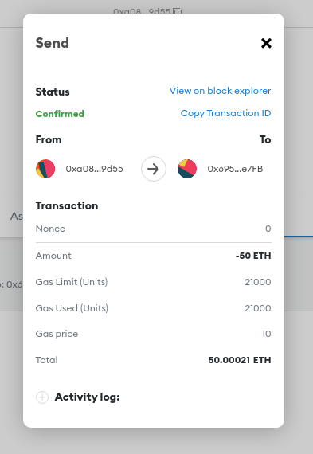

We can then see from the client that our balance has changed:

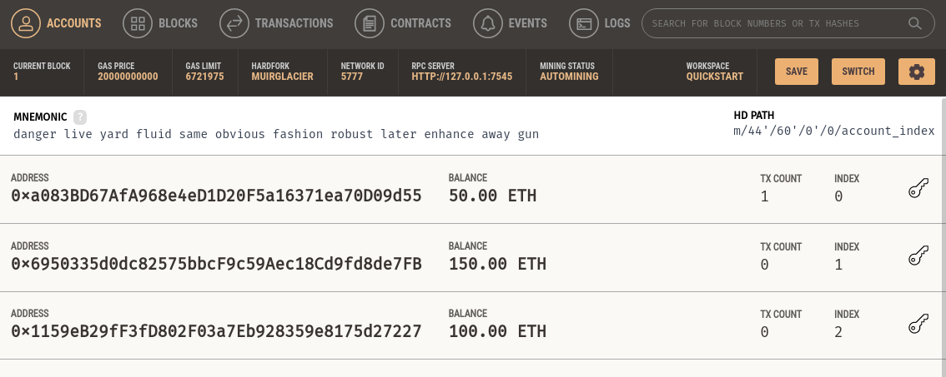

And we can see from the explorer that a block was mined with the transaction:

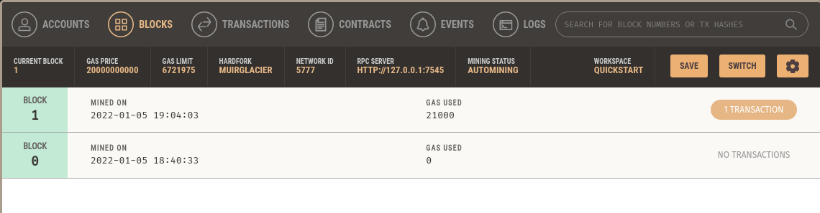

We are now set up with a local development blockchain!